GREAT PRIZE MONEY
(Including
(Trophies)
DENILIQUIN PASTORAL & AGRICULTURAL SOCIETY SHOW
Riverina Shearing Championships
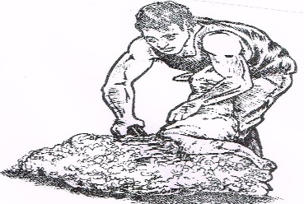
3rd & 4th March 2017

Friday Quick Shear
Open, Senior, Intermediate
Contractors Team Challenge
Friday Night Only
Buy a table right in front of the Shearing

Saturday
*Open * Senior
* Intermediate
*Learners
*Wool Handlers
McCalman
Shearing
0408629562

*Novice Handlers
Limited Positions & Tables (Friday Night only)
Entry Early
Forms available on
www.deniliquinshow.com

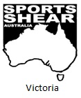

Entries Close 25th February 2017
Entry Form: www.deniliquinshow.com
Entry Co-ordinator: Brian Sullivan -0429815816

