The Pastoral and Agricultural Society of Deniliquin Ltd
Saturday 4th March 2017
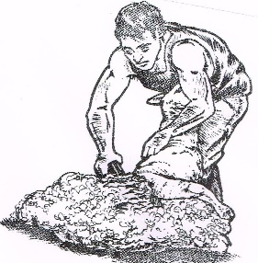
Riverina Shearing Championship
Competitors are required to check in at 8am
9am Start
 | Open | $50
 | Senior | $40
 | Intermediate | $30
 | Learners
 | Novice Wool Handler
 | Open Wool Handler | $30

Ernie Beehag Memorial Trophy: Best Local Shearer…………1st – 4th Place

Name:……………………………………………….Left handed shearers YES
Address:
…………………………………………………………………………
…………………………………………………………………………

Competitors Signature:………………………………….Date:………………….

- Entries close: 25th February 2017
- PO Box 128 Deniliquin NSW 2710
- All Competitors must pay gate admission
- Competitors compete at their own risk
(recommend that each competitor be self insured)
- Competition Rules Apply
Co-ordinator: Brian Sullivan 0429815816

