The Pastoral and Agricultural Society of Deniliquin Ltd
3rd March 2017

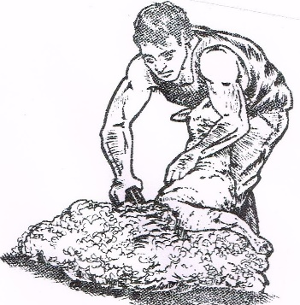
Friday Starting 5pm
Riverina Pro Quick Shear
 | Section | Entry Fee
 | Open | $50
 | Senior | $40
 | Intermediate | $30
 | Contractors Team Challenge

Name:……………………………………………….Left handed shearers YES
Address:
………………………………………………………………………………….
…………………………………………………………………………………..

Competitors Signature:………………………………….Date:………………….

- Entries close: 25th February 2017
- PO Box 128 Deniliquin NSW 2710
- All Competitors must pay gate admission
- Competitors compete at their own risk
(recommend that each competitor be self insured)
- Competition Rules Apply

Co-ordinator: Brian Sullivan 0429815816

